1- what is docker
A - فاش غدي نحتاجو دوكير متلا خدامبن على بروجي وكل واحد عندو فرسيون 8نود بهب بيتون8 خدام بيها غدي نحتاجو اننا نانستاليو نفس الفيرسيون و جميع الاشياء لغدي نحتاجو و هنا فين كبن لموشكبل لهدا غدي نخدمو ب دوكر
B - وتخيل معبا لحريرة لغدي تكون اننا غدي نكونو خدامين مجموعة من الناس على مجموعة من المشاؤيع
C - containers يعني كل كونتينر فيها داكشي لغدي نحتاجو الاصدارات لغدي نحتاجو
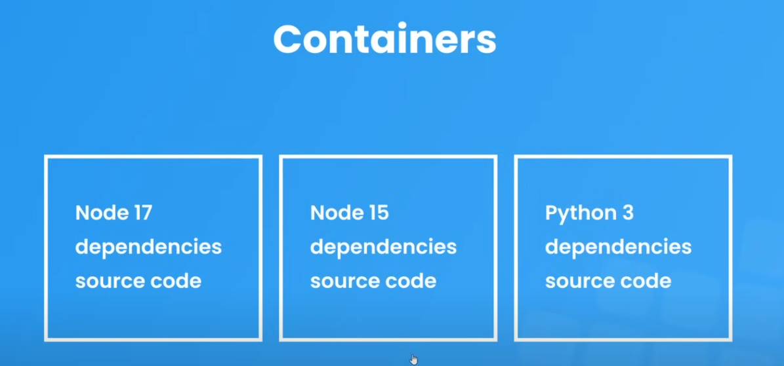
2- what is images and containers
- these are fundamental concepts in containerization technology, particularly in Docker.
Images :
Think of an image as a blueprint or template
It's a read-only file that contains:

The application code
Required dependencies
Configuration files
Runtime environment (like node version)
Operating system libraries
Containers :
- A container is a running instance of an image
- It's like creating a live, working copy from the blueprint
- Containers are:
  - Isolated environments
  - Have their own processes
  - Their own network interfaces
  - Their own file systems
_________________________________________________________
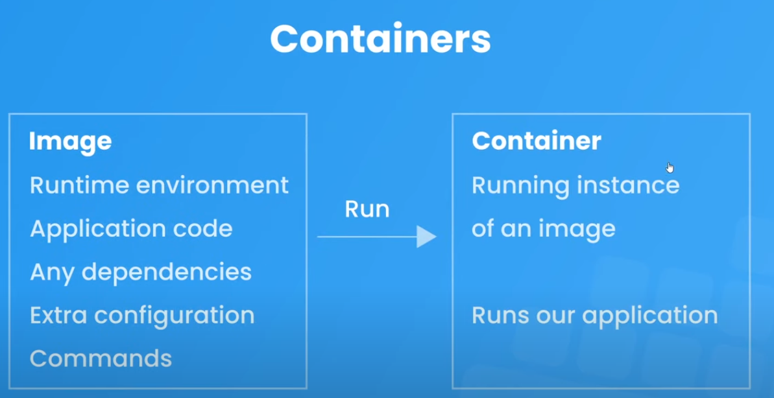
MY CODE= image MY PC system environment = container

Image :
It consists of: layers الترتيب مهم
1- parent image its system and environment
2- source code
3- parent image

what is parent image and docker hub
1 - parent image is the foundation image upon which you build your own Docker images, using the FROM statement in your Docker file link : FROM Ubuntu:20.04
2 - Docker Hub is like GitHub for Docker images, Storing images, Sharing images, Managing images

haw to run docker

sudo apt update
sudo systemctl start docker
sudo systemctl enable docker
sudo docker --version
sudo docker run hello-world

haw to Using Official Node Image https://hub.docker.com/_/node

Pull Node.js image
sudo docker pull node:latest
Run Node.js container
sudo docker run -it node:latest

Useful Docker Commands for Node.js:
# List running containers
docker ps
# Stop container
docker stop container_id
#docker start contaner name
sudo docker start Container-Name
# Remove container
docker rm container_id
# List images ___________________
docker images
# Remove image
docker rm image_name
docker rm image_name -f
# View container logs
docker logs container_id
# Enter running container
docker exec -it container_id bash

#container exist
sudo docker ps -a
#build image TAG Version
sudo docker build -t myapp:v1 .
#run container TAG Version
sudo docker run --name firs-C -p 4000:4000 myapp:v1
#add -i
docker start -i myappin
# Starts the container and attaches to its STDIN (input)
# You can see the container's output
# You can interact with the container's process

Create DockerFille : as a layers
A Dockerfile is like a recipe that tells Docker how to build an image.

FROM node:17-alpine first node and linux

WORKDIR /app work fille

COPY . . copy fille

RUN npm install install ...

EXPOSE 4000 port required for docker desktop port mapping

CMD ["node", "app.js"] run app

FROM node:17-alpine → • This is like choosing your base computer setup • It gets Node.js version 17 with Alpine Linux (a small, simple version of Linux) • Think of it as the foundation of your house
WORKDIR /app → Tis creates and sets a working directory called '/app' in your container
- Like creating a new folder and moving into it
Similar to doing mkdir app and cd app
COPY . . → Copies all files from your current directory (where Dockerfile is) into the container's '/app' directory , Like copying all your project files into the new folder , The first . means "everything in current directory" , The second . means "paste here" (in /app)
RUN npm install → Installs all your Node.js and package.json dependencies
- Like running npm install on your computer
EXPOSE 4000 → Tells Docker that your app will use port 4000
CMD ["node", "app.js"] → This is the command to start your application

Create or build image

1 - sudo docker build -t myapp . → my app its name image

Run the image

sudo docker run -p 4000:4000 myapp
sudo docker run myapp
Run the image in container
give name for container sudo docker run --name firs-C-myapp myapp
sudo docker run --name firs-myapp -p 4000:4000 -d myapp
p- pablice d- الفصل

Dockerignore :

.Dockerignore هو ملف يخبر Docker بالملفات والدلائل التي يجب استبعادها عند نسخ الملفات إلى صورة Docker أثناء عملية البناء.
: الفوائد الرئيسية:
- تقليل حجم الصورة
- تسريع عملية البناء
- منع تضمين الملفات الحساسة
- تجنب نسخ الملفات غير الضرورية

نحن نستبعد عادةً وحداتلأنها node_modules :
- كبيرة ويمكن إعادة بنائها داخل الحاوية
- قد تحتوي على تبعيات خاصة بالمنصة
- يمكن تثبيتها باستخدام package.json وnpm install

Example .dockerignore: → node_modules

Layer Caching :

- التخزين المؤقت للطبقة هو آلية حيث تقوم كل تعليمات في عملية بناء الحاوية بإنشاء طبقة، ويمكن إعادة استخدام هذه الطبقات في عمليات البناء اللاحقة لتسريع العملية.
It helps speed up the build, as we take the files that did not have to be changed from the layer Caching .

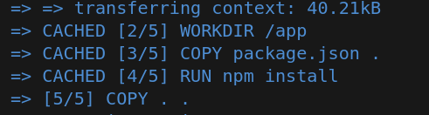

Remove all conatiner and images
sudo docker system prune -a

VOLUMES :
nodemon :
- دعني أشرح لك كيفية استخدام Nodemon في Docker للتطوير. Nodemon هي أداة تراقب ملفات تطبيق Node.js الخاصة بك وتعيد تشغيل الخادم تلقائيًا عند تغيير الملفات.
add RUN npm install -g nodemon in Dockerfile
and will change this
CMD ["node", "app.js"]
to this.
CMD ["npm", "run", ”dev”]
add build and run container

if you stop container remove outomaticly
sudo docker run --name myapp-C -p 4000:4000 --rm myapp:nodemon

outomaticly update build
sudo docker run --name myapp-C1 -p 4000:4000 --rm -v /home/devdriss/DockerizationAppReact/docker-crash-cou
rse-lesson-5/api:/app -v /app/node_modules myapp:nodemon

Docker Compose
Docker Compose - it's a tool for defining and running multi-container Docker applications.

# Start services docker-compose up
# Start in detached mode docker-compose up -d

# Stop services docker-compose down
# remove container and image and fille docker-compose down –rmi all -v
# View logs docker-compose logs
# List services docker-compose ps

Create file insite project → docker-compose.yaml
version: "3.8"
services:
api:
build: ./api
container_name: api_c
ports:
- '4000:4000'
volumes:
- ./api:/app
- ./app/node_modules

after this go to inside project and run this
docker-compose up

# Start containers in detached mode (run in background)
sudo docker-compose up -d

# Start containers and rebuild images
sudo docker-compose up --build

# Stop all containers
sudo docker-compose down

# Stop containers and remove volumes
sudo docker-compose down -v

# Start specific service
sudo docker-compose up service_name

# Scale a specific service
sudo docker-compose up -d --scale service_name=3

# View logs of all containers
sudo docker-compose logs

# View logs of specific service
sudo docker-compose logs service_name

# Follow log output
sudo docker-compose logs -f

# List containers
sudo docker-compose ps

# List running processes inside containers
sudo docker-compose top

# Execute command in running container
sudo docker-compose exec service_name command

# Stop all containers but keep volumes
sudo docker-compose stop

# Restart all containers
sudo docker-compose restart

# Force recreation of containers
sudo docker-compose up -d --force-recreate

# View docker-compose configuration
sudo docker-compose config

# Remove all stopped containers
sudo docker-compose rm

# Pull latest images
sudo docker-compose pull

# Build images without starting containers
sudo docker-compose build

# Show resource usage statistics
sudo docker-compose top

